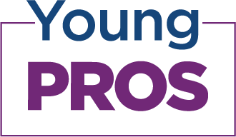
The ARF Young Pros wants to know about you!
Fill out this form for a Young Pro Spotlight feature

Name: |  | Age:
What is your role / current company?
When did you join the Young Pros?
Social Handle(s) | Twitter: Instagram: LinkedIn: Facebook:

Please answer 3-5 questions below *Please keep responses under 3 sentences
What is your proudest professional accomplishment?
What is your biggest
professional challenge?
How has being an ARF Young Pro
member impacted your career?
What’s your favorite Young Pros event
that you’ve been to?
When researching a topic you know
nothing about, how do you get started?
What’s an example of a company/ brand
that you think is doing a great job?
What is your favorite restaurant
in your city?
What is your favorite show/program?
What’s your dream job? (If money was
no object, what would you do?)

*Please email form, along with a head shot photo, to Gwen LaFantasie (glafantasie@thearf.org)
**By submitting this form, I consent that my spotlight/information can be shared on the ARF Young Pros web page and social platforms

